**Arquitectura Modulo Facturación Electrónica E Localización Argentina 2016**

1. FEEXP.dll:
   1. Desarrollado en Visual Basic 2005
   2. Clases:
      1. CertificadosX509Lib:
         1. Function FirmaBytesMensaje(ByVal argBytesMsg As Byte(),ByVal argCertFirmante As X509Certificate2) As Byte()
         2. Function ObtieneCertificadoDesdeArchivo(ByVal argArchivo As String, ByVal argPassword As SecureString) As X509Certificate2
      2. LoginTicket:
         1. Function ObtenerLoginTicketResponse( _

ByVal strIdServicioNegocio1 As String, _

ByVal strUrlWsaaWsdl1 As String, _

ByVal strRutaCertSigner1 As String, _

ByVal argPassword As SecureString, _

ByVal argProxy1 As String, _

ByVal argProxyUser1 As String, _

ByVal argProxyPassword1 As String, _

ByRef UniqueId As String, _

ByRef GenerationTime As Date, _

ByRef ExpirationTime As Date, _

ByRef Sign As String, _

ByRef Token As String, _

ByRef sErr As String _

) As String

* + 1. Main:
       1. Function ConsultaCAE(ByVal cuit As String, _

ByVal strToken As String, _

ByVal strSign As String, _

ByVal tipo_cbte As String, _

ByVal punto_vta As String, _

ByVal cbt_desde As String, _

ByRef cbte_estado As String, _

ByRef vencimiento_cae As String, _

ByRef cbte_cae As String) As Boolean

* + - 1. Function FileExists(ByVal FileFullPath As String) As Boolean
      2. Function gGrabaLog(ByVal Texto As String)
      3. Function ObtieneFEXCAE(ByVal strUrl As String, _

ByVal strToken As String, _

ByVal strSign As String, _

ByVal cuit As String, _

ByVal Id As String, _

ByVal cbte_nro As String, _

ByVal fecha_cbte As String, _

ByVal cbte_tipo As String, _

ByVal punto_vta As String, _

ByVal tipo_expo As String, _

ByVal permiso_existente As String, _

ByVal detPermisos As String, _

ByVal dst_cmp As String, _

ByVal cliente As String, _

ByVal cuit_pais_cliente As String, _

ByVal domicilio_cliente As String, _

ByVal id_impositivo As String, _

ByVal moneda_id As String, _

ByVal moneda_ctz As String, _

ByVal obs_comerciales As String, _

ByVal imp_total As String, _

ByVal obs As String, _

ByVal detCmps_asoc As String, _

ByVal forma_pago As String, _

ByVal incoterms As String, _

ByVal incoterms_ds As String, _

ByVal idioma_cbte As String, _

ByVal detItems As String, _

ByVal detOpcionales As String) As String

* + - 1. Function ObtieneLastCmp(ByVal cuit As String, _

ByVal token As String, _

ByVal sign As String, _

ByVal tipo_cbte As String, _

ByVal punto_vta As String) As String

* + - 1. Function ObtieneLastICbte(ByVal strToken As String, _

ByVal strSign As String, _

ByVal cuit As String, _

ByVal strUrl As String, _

ByVal Punto_vta As String, _

ByVal Cbte_Tipo As String) As String

* + - 1. Function ObtieneLastID(ByVal strToken As String, _

ByVal strSign As String, _

ByVal cuit As String, _

ByVal strUrl As String) As String

* + - 1. Function ObtieneMonCot(

ByVal url As String, _

ByVal cuit As String, _

ByVal token As String, _

ByVal sign As String, _

ByVal Mon_id As String) As String

* + - 1. Function ObtieneMoneda(ByVal strToken As String, _

ByVal strSign As String, _

ByVal cuit As String) As String

* + - 1. Function ObtienePais(ByVal strToken As String, _

ByVal strSign As String, _

ByVal cuit As String, _

ByVal url As String) As String

* + - 1. Function ObtieneTicket(ByVal strIdServicioNegocio1 As String, _

ByVal strUrlWsaaWsdl1 As String, _

ByVal strRutaCertSigner1 As String, _

ByVal strPasswordSecureString1 As String, _

ByVal strProxy1 As String, _

ByVal strProxyUser1 As String, _

ByVal strProxyPassword1 As String) As String

* + - 1. Function ObtieneUM(ByVal strToken As String, _

ByVal strSign As String, _

ByVal cuit As String, _

ByVal url As String) As String.

1. Ventanas:
   1. Administración-Configuración->Compañía:

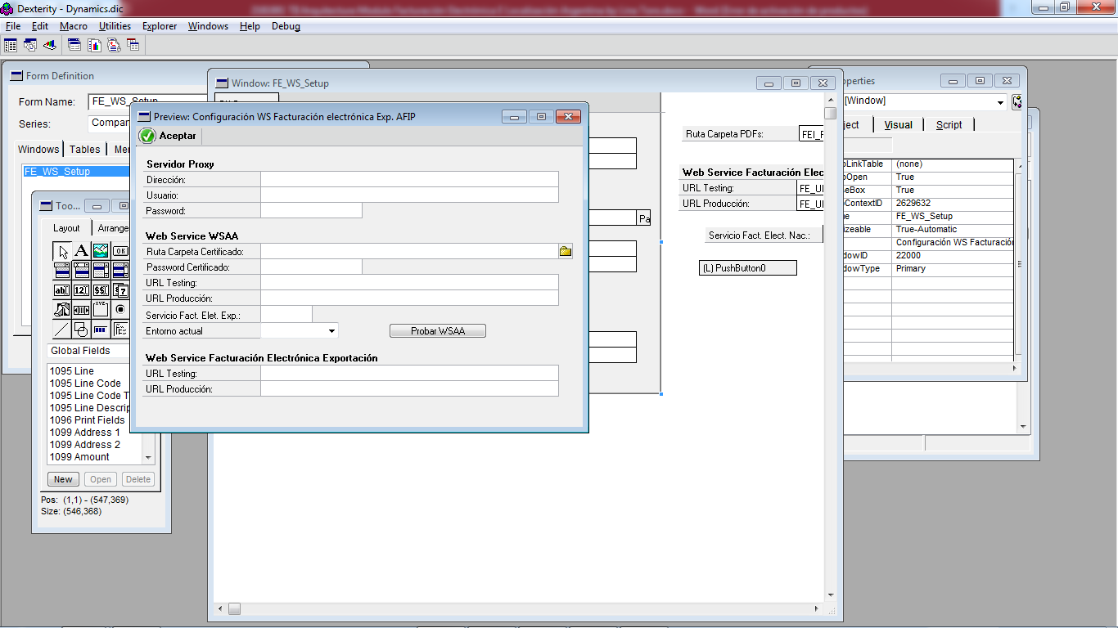

* 1. Ventas->Transacciones->Entrada transacciones de ventas->Adicionales

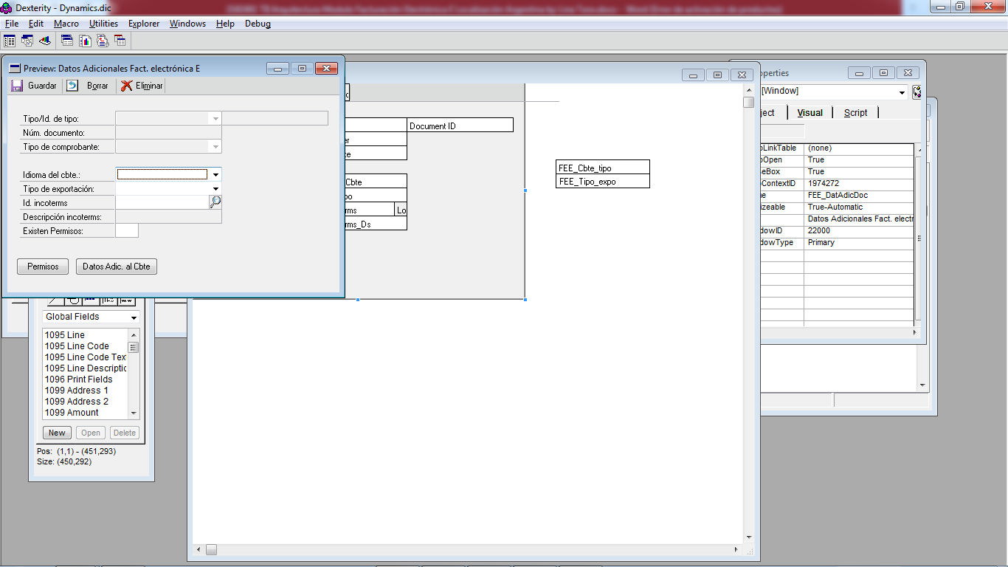

* 1. 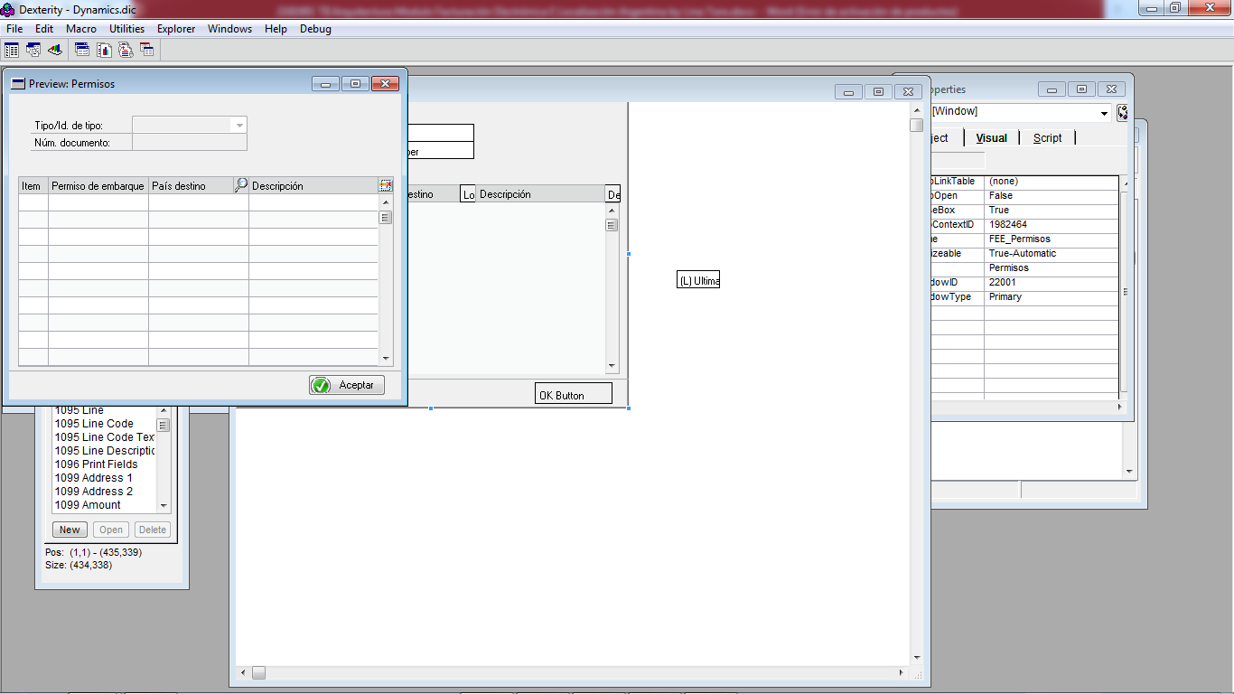Botón Permisos:
  2. 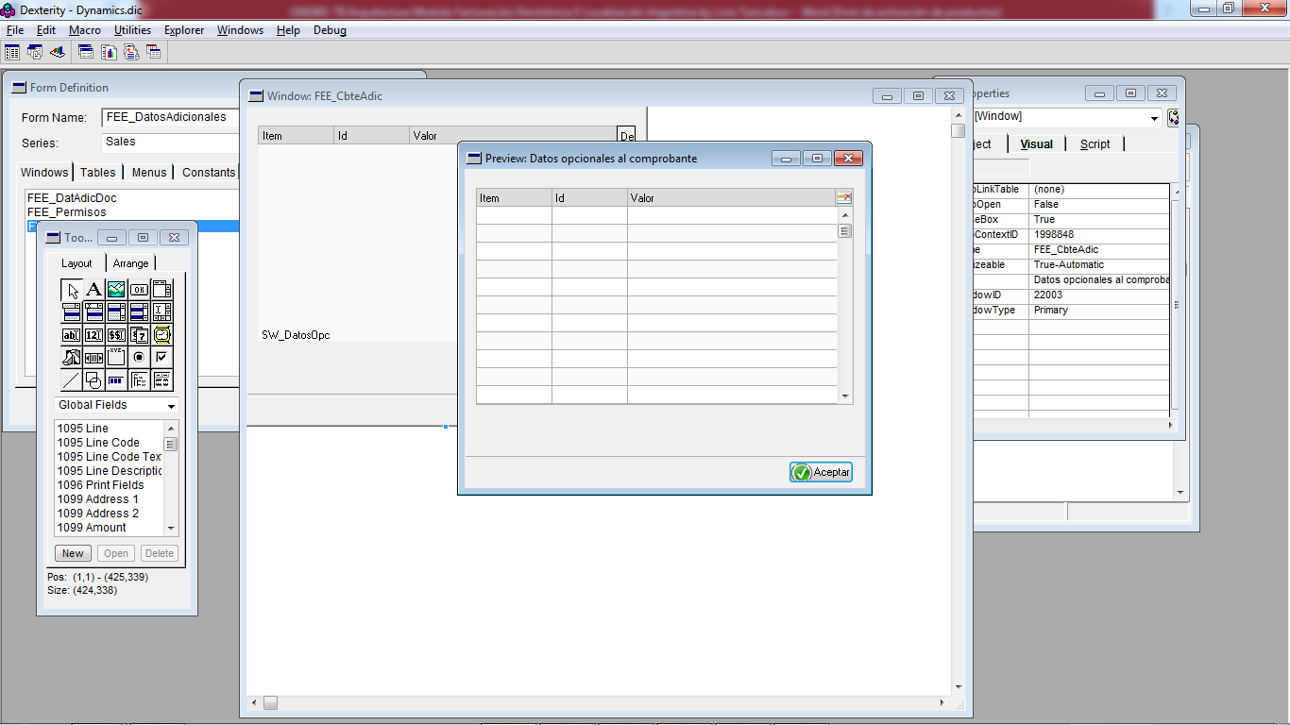Botón Datos adic. Cbte.
  3. Botón Guardar en la ventana Entrada transacciones de ventas:

